Loaders

## Front End Loader

**Category:** Loaders

**Tag:** Tractor Mounted material loading implement

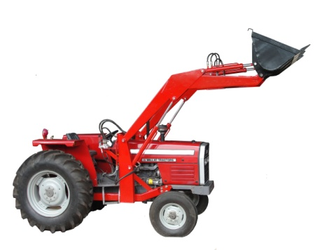 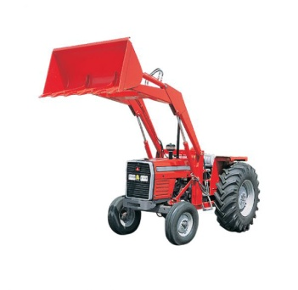

## Description

It is hydraulically operated mechanized solution for loading stones, bricks, crush, garbage, sand, grain and others. It can be used for multipurpose handling, loading and unloading purposes. It is a multipurpose, Rugged, Powerful Loader for General and Farm. It is installed on tractor’s hydraulic output and to maintain its performance, we used quality hydraulic cylinders. The hydraulic system is easy to assemble and maintain. It is simple to handle with quick detachable bucket link and replaceable earth digging teeth. Front end loaders are available with lifting capacity varying from 800 – 2000 KG that depends upon the tractor compatibility. It contains 2 double acting arms for lifting and 2 for bucket titling. We have different models of frond end loaders available with independent hydraulic pump, oil reserve tank, counter weight box and canopy of tractor.

|  |  |
| --- | --- |
| Specifications | |
| Lifting Capacity | 800 KG |
| Bucket Size | 60'' - 66'' |
| Lifting Height | 132'' |
| Rod | Hard Chromed Carbon |
| Cylinders | 4 |
| Control Valve | 4 Spool Valve |
| Hose Pipe | 6000 PSI Double Breaded |
| Power Requirement: | 60 - 85 HP |